1. Open the [ModuleFiveAssignment.ipynb](https://snhu.brightspace.com/content/enforced/1009040-CS-340-T4528-OL-TRAD-UG.22EW4/course_documents/ModuleFiveAssignment.ipynb?_&d2lSessionVal=WDPVnBcYdTuBHQh4LaVearPY7&ou=1009040) file, which contains the starter code for the dashboard and the authentication interface. Upload this file into Apporto and open it using the Jupyter Notebook application. Be sure to review all of the starter code that you have been given. Pay special attention to the import commands and the comments describing what each section of code does.

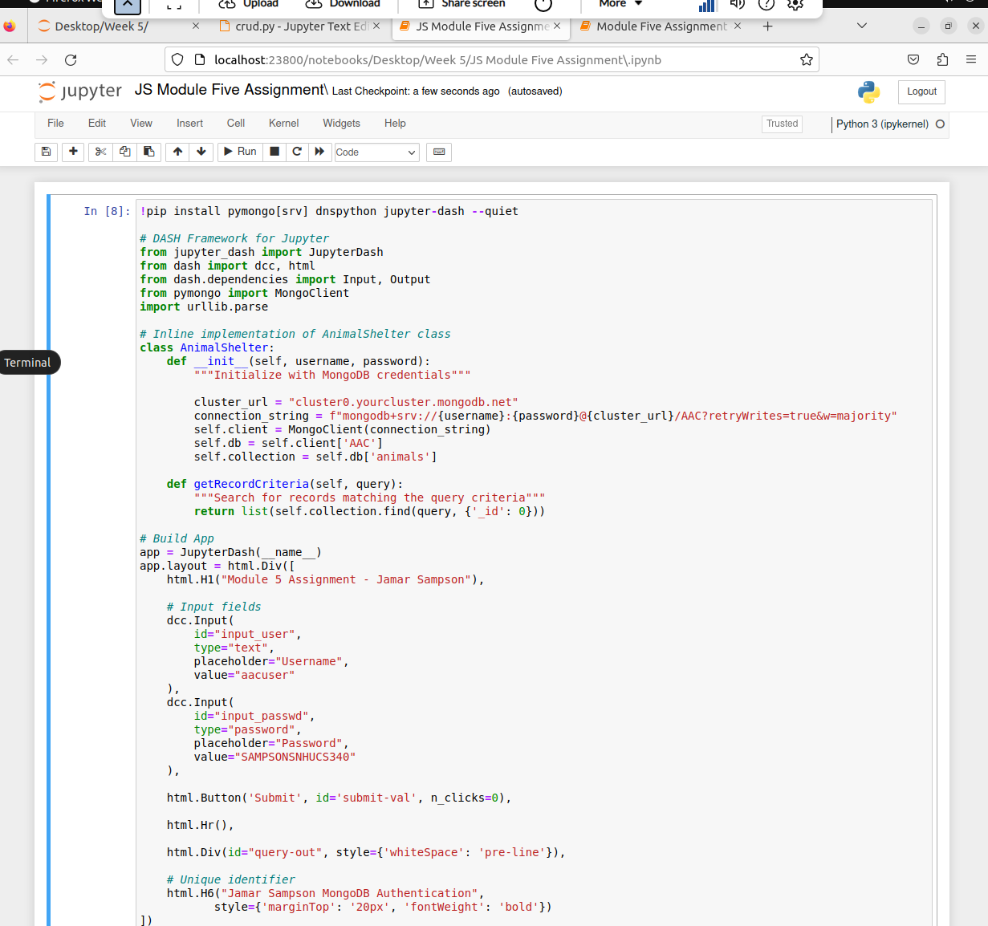

1. The code that you have been given provides you with a very basic dashboard. Add an **HTML component, such as a header, to create a unique identifier** for your dashboard. This unique identifier could be your name or a specific handle or image that is unique to you.
2. Customize the starter code that you have been given by developing connections between the dashboard username/password interface and your CRUD Python module. The dashboard should prompt the user for their username and password, and return the output of the test query. Be sure to complete each of the following.

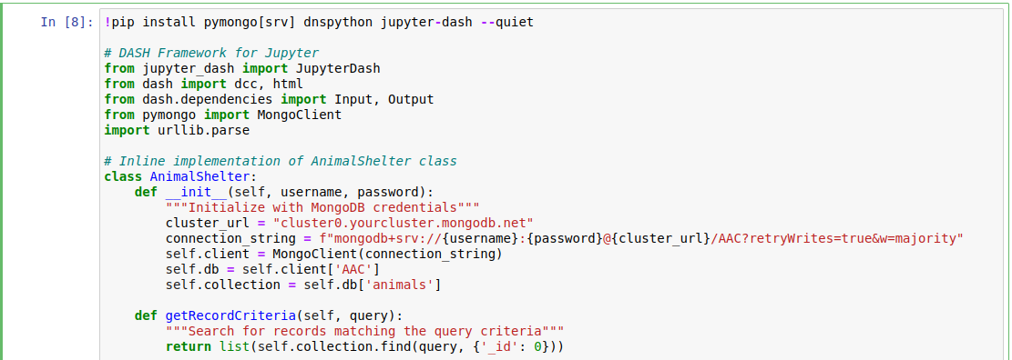

1. **Add the functionality in the callback routine for instantiation of your CRUD object**. Remember to apply the user authentication when creating your CRUD object.

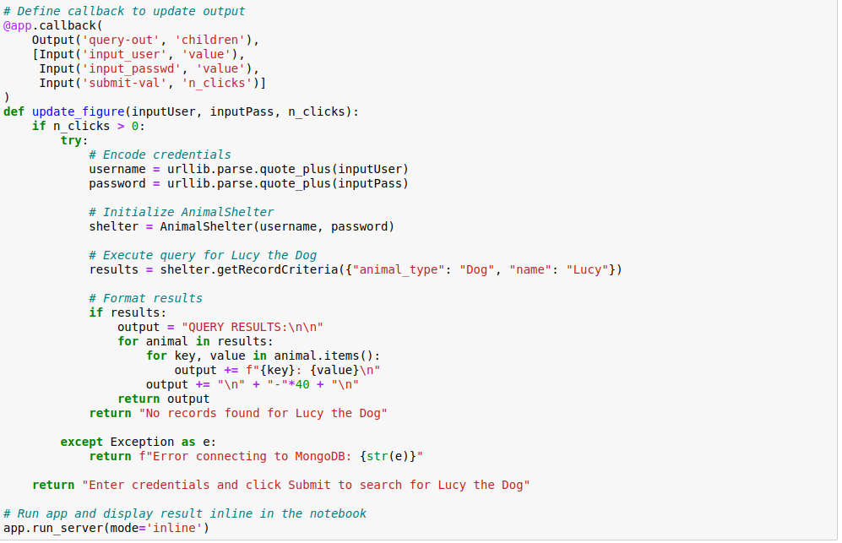

1. Finally, **add functionality to test your dashboard connection to MongoDB**. To do this, write code that returns the following read query: {"animal_type" : "Dog","name" : "Lucy"}.

**IMPORTANT: Use the “aacuser” account and the password that you set up in the Module Three milestone.**

Take a **screenshot** of your dashboard as proof of this execution. Your screenshot should show the prompt for the username and password, and then the result of your test query. Your unique identifier should also be visible in the screenshot.

